Designing the World Around Me – Project in Citizenship and Maths PiCaM

Project Kit description
Difficulty level
Easy
Key competences
Mathematical, personal, social, civics, digital, languages
Subjects
Mathematics/ Geometry, Social sciences, History, Religion, Cross Curricular
Level
10-14
The activity supports the development of geometric understanding through the use of two dimensional shapes in cultural and religious symbolism and through their use in architecture, particularly in the use of tiling. Throughout there are opportunities for exploring how symbolic representations are underpinned by ideas and beliefs.
The mathematical content relates to: names and properties of two dimensional shapes; reflective and rotational symmetry, factors, primes ad co-primes; regular and semi-regular tiling
Pedagogical objectives
- Applying mathematical knowledge and skills to further understand the nature of social relationships
- Using geometry (shapes and patterns) to improve own perspective on social relationships
- Establishing inclusive social relationships
- Developing a view on European partner’s cultural heritage and religious background
- Putting in relation geometric shapes, their social (attributed) meaning and their use in decorating significant institutions
Mathematical competences
- looking for patterns and connections
- asking yourself questions
- visualising, imagining and using intuition
- using argumentation and reasoning
- recognising the social and ethical dimensions of mathematics
- questioning the use of mathematics in structuring experience of the world
Global citizenship competences
- appreciate different perspectives & world views
- positive interactions with people who are different
- take constructive action for social well-being
- analytical & critical thinking skills
- communication & co-operation skills

 | Communication |  | Collaboration

The activity requires whole class teaching plus small groups work. Students from different countries collaborate using the Internet.
Task 1: Designing with regular polygons. Starting from stimulus such as old and new buildings design, students discuss the use of basic geometric shapes and try to reproduce complex tiling by identifying patterns and tiling rules.
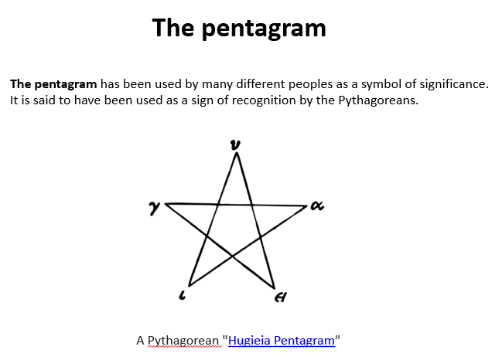
Image: https://commons.wikimedia.org/wiki/File:Hugieia-pentagram.svg
Task 2: Pentagonal symmetries. In a circle, students are throwing a ball one space around the circle, then two spaces and so on, to find out how many spaces would make a pentagon and how this would be possible. In small groups, they discuss and draw different possibilities. With their teacher, they use ratio and fractions to explore other ideas and expand their designs.
Task 3: Exploring patterns in point circles. Exploring point circle patterns further allows rich opportunities to think about factors, prime and co-prime numbers.
Task 4: Designing a symbol to represent our class. Starting from a variety of symbols from different cultures and historical times, students design an original symbol for their class, then they try to draw a geometrical representation for their relationships as a group.
The class may wish to share their symbols through eTwinning, explaining, in short, the significance behind their drawing.
Task 5: Exploring tiling mathematically. Girih designs can be studied, revealing the advanced mathematical knowledge of medieval Islamic designers.
Other correspondences between mathematically determined design and the natural world can be used. The students may like to consider if there are other types of correspondences – between mathematics and soul, for instance.
Task 6: Tiling patterns in the world around me. The students look for tiling patterns in the environment. They take photographs to share and discuss the mathematical properties of the tilings they have found.
Task 7 (optional): Reflection on the nature/ rules of the social world around me. Students think if the social relationships could be represented geometrically and what would be the rules.
There are number of approaches for the discussion. For example:
(1) Similarities & differences.
Think of the points or circles you use to represent each of you. Do they have the same (colour and) size? Why not? Doesn’t this add some beauty to the world?
Think of the lines connecting you in pairs. Are they equal? Why not?
What is putting us close and what is setting us apart?
(2) Present & future. Permanent & changing. The evolving nature of human relationships.
It is likely that the groups of friends you are in will change over time – class members with whom you barely speak now can become your best friends. What is then the value of the drawing you would do now to represent the relationships in your class? Could you ever do a tiling for this?
Creating connections. Think of how you first met your best friend. Were you friends from the beginning or you become friends over time?
The world is a moving tile. What would be necessary to become friend with somebody from the other part of the world?
(3) Subjective versus objective.
If an external person who didn't know you at all represented your class, would the drawing look different? Would the circles representing each pupil be the same? What about the lines connecting you – would they have the same length? What does this mean?
Do you think you could find something in common with every child on this planet?
The discussion(s) can be reflected by each student (or by small groups of students) on a vision board, by using a digital tool such as Padlet, WordArt, Lino etc. – as homework. Their vision boards will be shared among all eTwinning project partners.

Evaluation & Assessment

Expected results
Overall intended learning outcomes could include the ability to:
- recognise two dimensional shapes
- classify shapes using various criteria
- provide examples of the use of different shapes for decoration
- identify and construct regular and semi-regular tiling patterns
- see patterns involving factors, primes and co-primes
- identify the main universal symbols (such as religious symbols)
- put in relation geometric shapes, their social (attributed) meaning and their use in decorating significant institutions
- use shapes and patterns in order to represent (social) relations
Assessment
Project-based learning principles can be used throughout the activity, allowing continuous direct assessment of individual and collaborative work, participation, progress, but also individual and group products of activities.

Follow up

Possible discussion themes to be explored further starting from the students’ drawings attempting to represent their class and their discussion about picturing social relations are:
- equality
- diversity
- inclusion
- equity
They should probably be approached in-depth in a civic education class or in a dedicated non-formal activity involving all class members.

This activity is a suggestion that you may use by adapting and completing it as you and your students need.
A complete learning path ”Designing the World Around Me: Mathematics and Cultural Inspiration in Design” is available on PiCaM website.
For other PICAM learning activities, visit citizenship-and-mathematics.eu website – Resources section

