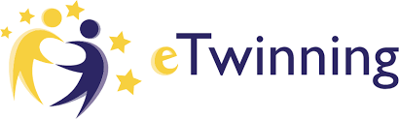

Mapping Our World with Mathematics – Project in Citizenship and Maths PiCaM

Project Kit description
Difficulty level
Intermediate
Key competences
Mathematical, personal, social, civics, digital, languages
Subjects
Mathematics/ Geometry, Social sciences, Geography, History
Level
10-13
The activity explores the history of European colonisation through studying maps and globes. The ways in which representations can intentionally or otherwise mislead is addressed.
The mathematical content refers to: area, length, angle and properties of circles on a sphere - equator, pole, latitude and longitude; large numbers, percentages and bar charts read, compared and interpreted; decimals and ratios.

Pedagogical objectives
- Applying mathematical knowledge and skills to further understand cultures, communities and different perspectives upon our world
- Integrating History, Geography and Mathematics to explain and to fight prejudices and cultural inequalities and hierarchies
- Understanding the benefits and the drawbacks of migration colonialization, natural increase and decrease of population
- Seeing their country in its historical and geographical place in the world
- Identifying and developing intercultural relations
Mathematical competences
- looking for patterns and connections
- asking yourself questions
- conjecturing and checking things out
- using embodied and multi-sensory approaches
- using representation and symbolism
- modelling and dealing with uncertainty
- using argumentation and reasoning
- recognising the political and ethical dimensions of mathematics
Global citizenship competences
- capacity to examine global issues
- appreciate different perspectives & world views
- analytical & critical thinking skills
- communication & co-operation skills

 | Communication |  | Collaboration

The activity requires a combination of small group work, whole class activity and collaboration using the Internet.
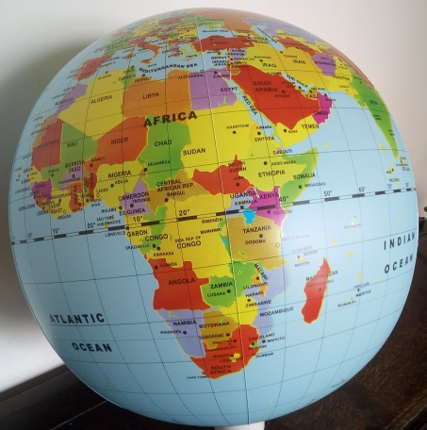
Task 1: Getting to know the globe each other. Students identify all the partners’ countries, play matching games, then explore distances by scaling up measurements, using a scale factor.
Task 2: Comparing colonies. Which is bigger - Algeria or France? India or the UK? Namibia or Germany? Brazil or Portugal? Students find similarities between the colonising countries and the colonised countries. Together with the teacher, they draw out where appropriate the legacies of colonialism - for example, language; current tension or conflict; aspects of current heritage; wealth distribution worldwide; patterns of discrimination.
Task 3: Mapping the globe. Using copies of the five types of globe representation, students compare them and discuss about the effects of changing the perspective.
Task 4: Which map is best? They can exchange their thoughts with peers in other countries, using a virtual board (such as Padlet).
Task 5: The true size of continents. With a copy of the chart ”Land mass and population of the seven continents”, students place the names of the continents on the ”Graph comparing land mass and population of continents”, then take a photo of their solution. As they finish, ask each group to write down some questions connected to the graph. Collect together questions from each group, one at a time, until all the questions are recorded.
Which of these questions can we use mathematics to explore? They choose some questions to be addressed to students in partner countries.

Evaluation & Assessment

The activity can be concluded by asking the children to discuss in groups what they have learnt from the project and to share this with others. Each child should then write or draw or photograph about something they have learnt. The group in one country then combine these to make a poster.
Alternatively, teacher can create a P4C (Philosophy for Children) discussion using the overall project as the initial stimulus: what questions arise for you from the Mapping our world with mathematics project?

Follow up

Possible extensions are: exploring further questions raised by examining the globe in the first task; studying the history and current state of a chosen colony following discussions in the second task; studying the history of the nation state and discussing groups marginalised by the concept, for example, in Europe the Roma and the Sami; representing the data from the third task in other ways, for example, by pie charts.

This activity is a suggestion that you may use by adapting and completing it as you and your students need.
A complete learning path ”Mapping Our World with Mathematics” is available on PiCaM website.
For other PICAM learning activities, visit citizenship-and-mathematics.eu website – Resources section

