Playing and Making Mathematical Games – Project in Citizenship and Maths PiCaM

Project Kit description
Difficulty level
Easy
Key competences
Mathematical, personal, social, civics, digital, languages
Subjects
Mathematics/ Geometry, Social sciences, Cross Curricular
Level
10-13
This activity creates spaces, inside and outside the school context, for children to collaborate and share experiences amongst themselves and with others through playing mathematical games or making mathematical crafts. The mathematics of the game or the craft becomes a way of signifying connections between words, bodies and algorithms.
The learning activity starts from exploring games such as:
- Tangrams and origami (spatial competences).
- Dominoes and number scripts (developing number sense in notation and symbolism).
- Other games or crafts can develop other specific mathematical content.
It is an opportunity for students to share alternative knowledge systems; to connect number and geometry with cultural and intercultural relations; to develop and exchange competences or ideas.

Pedagogical objectives
- Applying mathematical knowledge and skills to further understand the nature of social relationships
- Using mathematics to improve aspects of day-to-day life
- Developing a view on European partner’s cultural heritage and historical background by studying the local games, social practices, and communities
- Promoting collaborative work and developing creativity, critical thinking, algorithmic thinking, multiple intelligences
Mathematical competences
- using argumentation and reasoning
- recognising the political and ethical dimensions of mathematics (as in creativity)
- looking for patterns and connections
- being organised and systematic
- conjecturing and checking things out
Global citizenship competences
- appreciate different perspectives & world views
- positive interactions with people who are different
- take constructive action for sustainable development & social well being
- communication & co-operation skills

 | Communication |  | Collaboration

The activity requires a combination of small group work, whole class activity and collaboration using the Internet. Students and teachers share experiences of playing mathematical games and making crafts in their local contexts and explore similar practices amongst youth playing and making cultures across countries.
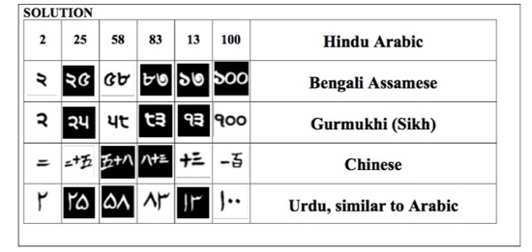
The emphasis is in sharing the joy and experience of playing and making. Such sharing can be sensed not only between children and adults of the community playing a particular mathematical game or craft making, but also amongst them as the unfolding of life-stories and getting to know each other, ideally in public spaces in the community.
1 Smile 1931. Copyright free. The origins of the scripts. www.stem.org.uk

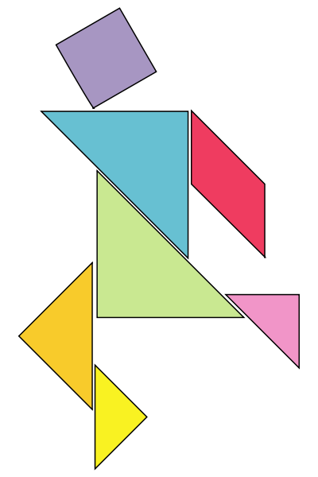
Task 1: Explore Mathematical Games or Crafts. Can be number scripts, dominoes or tangrams and crafts can be making origami, knots, robots and so on. Students have to spend time in learning how to play the game and make the craft (reading instructions, watching video tutorials and so on) and note down what they learned. Using the internet or other sources, they locate information concerning the cultural grounding or significance of the game or craft they have chosen. Which varied cultures are present in these games or crafts? What are the mathematical skills in number or spatial sense embedded in the process of playing the game and making the craft? How have these games or crafts changed over the years and how are they being used today? By young people, by the market, in industry, in digital culture?
2 Tangram puzzle. Source: commons.wikimedia.org/wiki/Tangram
A poster can be constructed by each group to present the games or crafts they have decided to explore, denoting not only the mathematical content in them, but also their significance in ancient, nomadic or contemporary cultures.
Task 2: Play a game! And, make a craft! Become an expert. Children are asked to identify techniques in playing their game or making their craft, as well as, to refine their own attempts in following a technique.
Task 3: Share your skilfulness. Students invite other children for friendly games or craft-making workshops. They learn from each other, sharing techniques and ideas in playing and making. What new things have you learned? What stories about how things are being made amongst all of you?

Evaluation & Assessment

Expected results
This activity aims to demystify how one may become skilled by unfolding the process through suggesting particular steps that aim to slow down the process, noticing rules and patterns, identifying techniques and refining them in the company of others.
Assessment
Project-based learning principles can be used throughout the activity, allowing continuous direct assessment of individual and collaborative work, participation, progress, but also individual and group products of activities.

Follow up

Competences and content from Mathematics and Social sciences curriculum can be addressed further, using different games and crafts proposed by students.
Other mathematical games and crafts can be also identified by children, in digital forms, such as video tutorials or instructions located in the internet.
Students can continue collaboration, using a virtual campus, by challenging each other to solve or to develop together new games, innovative crafts or new mathematical representations and solutions to existing (social) games.

This activity is a suggestion that you may use by adapting and completing it as you and your students need.
A complete learning path ”Playing and Making Mathematical Games and Crafts” is available on PiCaM website.
For other PICAM learning activities, visit citizenship-and-mathematics.eu website – Resources section

